Practical Assignment – 1

**1. Create a script to make the sum of all the integers between 0 and 30 and display the total.**

**=>** <?php

$i = 0;

$sum = 0;

for($i=1;$i<=30;$i++)

{

$sum=$sum + $i;

}

echo"sum of 1 to 30 is :" .$sum;

?>

**=>Output:**



**2. Create a script to construct the following pattern, using a nested for loop.**

**\***

**\* \***

**\* * \***

**\* * * \***

**=>**

<?php

for($a=0;$a<5;$a++)

{

for($b=0;$b<$a;$b++)

{

echo " * ";

}

echo "<br>";

}

?>

**=>Output:**



**3. Create a script to construct the following pattern, using a nested for loop.**

**\***

**\* \***

**\* * \***

**\* * * \***

**\* * \***

**\* \***

**\***

=><?php

for($a=0;$a<5;$a++)

{

for($b=0;$b<$a;$b++)

{

echo " * ";

}

echo "<br>";

}

for($a=0;$a<4;$a++)

{

for($b=3;$b>$a;$b--)

{

echo " * ";

}

echo "<br>";

}

?>

**4. Write a program to find the factorial of a number (non-negative integer).**

**=>**

<html>

<body>

<form>

<center>-----Factorial-----<br>

Enter number:

<input type="number" name="txt1" >

<input type="submit" name="factbtn" value="Submit"></center>

</form>

</body>

</html>

<?php

$fact=1;

if(isset($_GET['factbtn'])){

for($a=$_GET['txt1'];$a>0;$a--)

{

$fact=$fact * $a;

}

echo "Factorial of a is: ".$fact;

}

?>

**=>Output:**

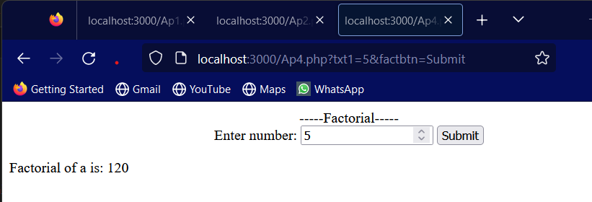

**5. Write a PHP program which will take your name as input from text box and display welcome ‘name’… on same page when click on submit button.**

**=>**

<html>

<body>

<form>

Enter your name:

<input type="text" name="txtname">

<input type="submit" name="btnsbt" value="Submit">

</form>

</body>

</html>

<?php

if(isset($_GET["btnsbt"]))

{

echo "welcome ".$_GET["txtname"]." ...";

}

?>

**=>Output:**



**6. Write a PHP program which will take your name as input from text box and display welcome ‘name’… on another page when click on submit button. (Use GET method and check URL).**

**=>**

**--Page 1—**

<html>

<body>

<form action="Ap6B.php">

Enter your name:

<input type="text" name="txtname">

<input type="submit" name="btnsbt" value="Submit">

</form>

</body>

</html>

**--Page 2--**

<?php

if(isset($_GET["btnsbt"]))

{

echo "welcome ".$_GET["txtname"]." ...";

}

?>

**=>Output:**





**7. Write a PHP program which will take your name as input from text box and display welcome ‘name’… on another page when click on submit button. (Use POST method and check URL).**

**=>--Page 1--**

<html>

<body>

<form action="Ap7B.php" method="post">

Enter your name:

<input type="text" name="txtname">

<input type="submit" name="btnsbt" value="Submit">

</form>

</body>

</html>

**--Page2—**

<?php

if(isset($_POST["btnsbt"]))

{

echo "welcome ".$_POST["txtname"]." ...";

}

?>

**=>Output:**





**8. Write a PHP program which will take two numbers as input from text boxes and display sum on same page when click on submit button.**

**=>**

<html>

<body>

<form>

No 1:

<input type="number" name="tb1" value="0">

No 2:

<input type="number" name="tb2" value="0">

<input type="submit" name="submit" value="Sum" >

</form>

</body>

</html>

<?php

if(isset($_GET['submit']))

{

$num1=$_GET['tb1'];

$num2=$_GET['tb2'];

echo $num1." + ".$num2." = ".($num1+$num2);

}

?>

**=>Output:**

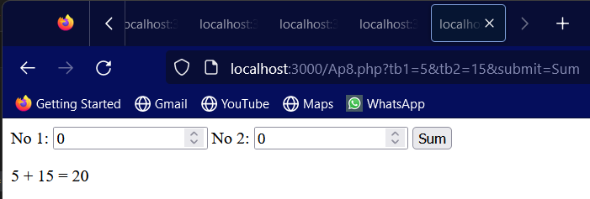

**9. Write a PHP calc program which will take two numbers as input from text boxes and display output according to click on ‘+,-,*,/’ button. After click on any button the values in text boxes do not have to change or remove, So for same values we can click on another button and get required result.**

**=>**

<html>

<body>

<?php

if(isset($_GET['sum'])|| isset($_GET['minus'])||isset($_GET['mul'])||isset($_GET['div']))

{

$num1=$_GET['tb1'];

$num2=$_GET['tb2'];

}

?>

<form>

No 1:

<input type="number" name="tb1" value="<?php echo $num1 ?>">

No 2:

<input type="number" name="tb2" value="<?php echo $num2 ?>">

<input type="submit" name="sum" value="+" >

<input type="submit" name="minus" value="-" >

<input type="submit" name="mul" value="*" >

<input type="submit" name="div" value="/" >

<?php

if(isset($_GET['sum']))

{

echo "<br>";

echo $num1." + ".$num2." = ".($num1+$num2);

}

if(isset($_GET['minus']))

{

echo "<br>";

echo $num1." - ".$num2." = ".($num1-$num2);

}

if(isset($_GET['mul']))

{

echo "<br>";

echo $num1." * ".$num2." = ".($num1*$num2);

}

if(isset($_GET['div']))

{

echo "<br>";

echo $num1." / ".$num2." = ".($num1/$num2);

}

?>

</form>

</body>

</html>

**=>Output**

